****PROGRAMMING LANGUAGES

**PROJECT NAME**

Writing a lexical analyzer for BigAdd Language

**STUDENT ID - NAME**

05190000108 – Hamit Can DAŞÇİ

05180000113 – Simge Merve YAŞBAY

**DUE :**

**Contents**



Analysis ..................................................................................................3

Design ....................................................................................................4

Source Code...................................................................................4

Test Data and Screenshot ………….…………………......................................14

4.Limitations..........................................................................................16

**ANALYSIS**



**DESIGN**

**Source Code:**

**3. TEST DATAS AND SCREENSHOTS**

**Test Datas:**

**Screenshots:**

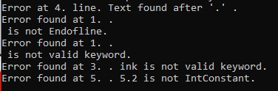

**4. LIMITATIONS**

